|  |  |  |
| --- | --- | --- |
| Contact:  Breeze Ettl, Director of Marketing  Phone: 269.983.0271  Email: bettl@krasl.org | 707 Lake Boulevard  St. Joseph, MI 49085 USA  www.krasl.org |  |

# Press Release

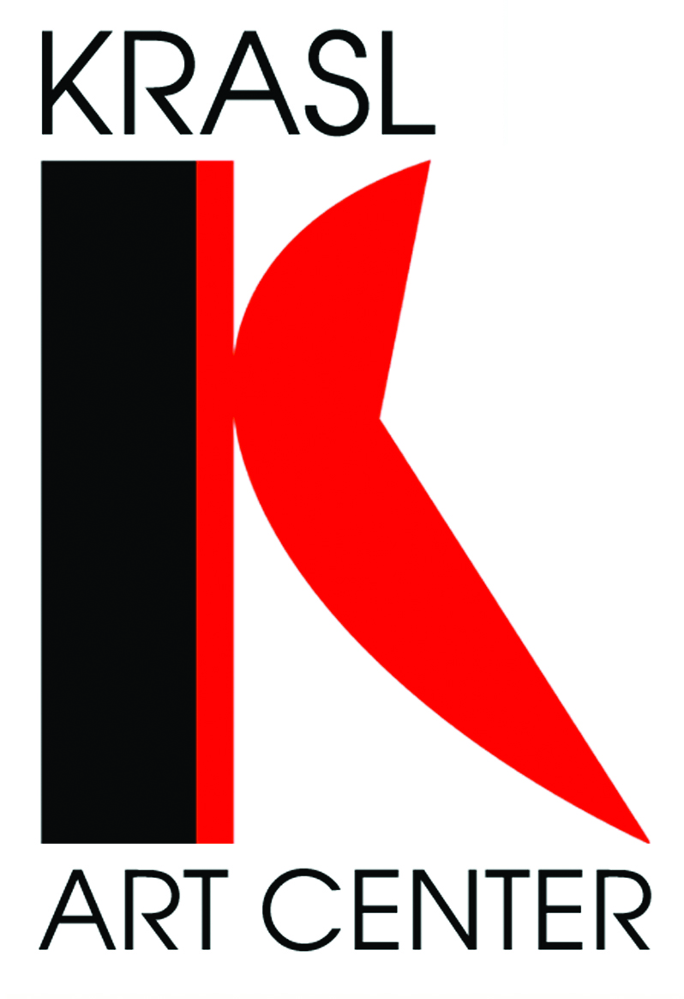

***Handmade, Fine Art Gifts at the Krasl***

Krasl Art Center Artisan Market and Soup’s On Opens November 10

For Immediate Release: St. Joseph, Michigan

October 31, 2016

**The Krasl Art Center’s** annual Artisan Market and Soups On begins Thursday, November 10 and goes through Sunday, November 13 at the Krasl Art Center, 707 Lake Boulevard in St. Joseph. Artisan Market is the only autumn, juried fine art and craft event in southwest Michigan.

Shop for fine, handmade gifts created by artists from around the region. Nearly 100 artists were selected for this year’s four day market. Featured items include unique jewelry, wearables, toys, home décor and more.

In addition to the market, the KAC ceramic artists have been creating soup bowls for purchase during Soups On. These one of a kind bowls are being sold for $10 each with all proceeds going toward the KAC Ceramic Studio. “Our ceramic artists worked long and hard to create soup bowls for this annual event. It’s wonderful to see the variety available for purchase and we’re especially pleased that 100% of the proceeds will support the ceramic studio,” said Nathan Margoni, KAC Education Manager.

New this year, Soups On happens every day during the Artisan Market Event from 11 am – 1:30 pm. Each day a different organization or restaurant provides specialty soups to support this fundraiser. The schedule is as follows: Thursday, Lake Michigan College Culinary Arts Students, Friday, Bistro on the Boulevard, Saturday, The Buck and Sunday, Zoup. Along with fabulous soup delicious bread and dessert is included for $10.

Among the favorite artists returning this year is Vicki Cook with her handcrafted jewelry. Vicki designs with sterling, fine silver, copper, brass and gold to create jewelry with intriguing complexity. Vicki teaches metal jewelry classes at the Krasl Art Center and the Kalamazoo Institute of Arts.

One of the new artists this year is Paula Baumann. Paula completed a B.F.A. in Fibers & Art History after retiring from Whirlpool. She is currently a fiber artist in Raleigh, NC where she spins, dyes and weaves fibers into décor and wearable art. Paula’s hand woven towels and socks will be available at the market.

Krasl Art Center Artisan Market is open Thursday, November 10, 10 AM-9 PM, Friday, November 11 – Sunday, November 13, 10AM-4PM

Soups On is open every day 11:00 – 1:30 PM Thursday, Nov. 10 through Sun. Nov. 13

**KRASL ART CENTER**

The Krasl Art Center is a 501(c) (3) non-profit organization. The Krasl Art Center is located in downtown St. Joseph, Michigan overlooking Lake Michigan. The KAC has three public galleries, five studios, a library/lecture room, a black and white wet darkroom, a gift shop, and a permanent collection of 42 works of sculpture. Through its mission to bring people and art together, the KAC offers thoughtful exhibitions, engaging classes and camps, community events such as Krasl Art Fair on the Bluff and the Artisan Market, outreach opportunities, and cultural exploration. The Krasl Art Center is funded in part by the Michigan Council for the Arts & Cultural Affairs and the National Endowment for the Arts.

The Krasl Art Center galleries are open Monday-Wednesday, Friday & Saturday from 10-4; Thursday from 10-9; and Sunday 1-4.  Admission to the galleries is free of change.  For more information, please contact the Krasl Art Center at 269.983.0271, or visit [www.krasl.org](http://www.krasl.org).

###