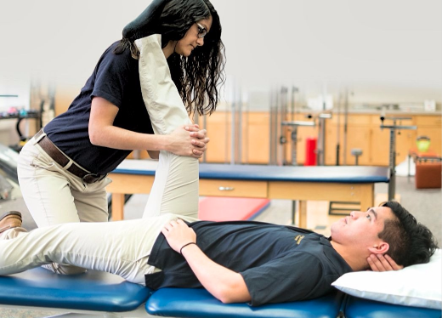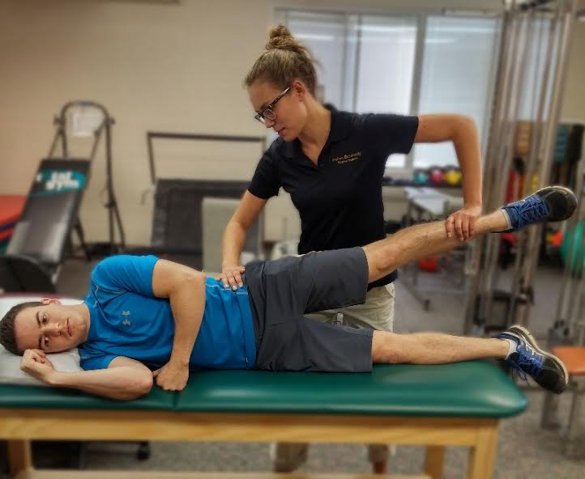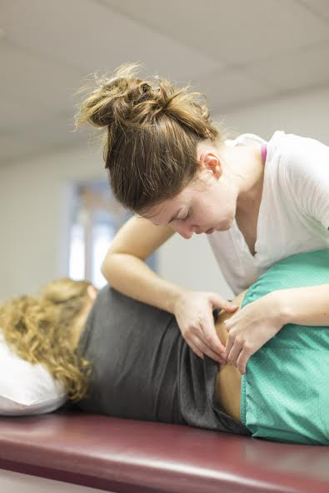

# FREE PHYSICAL THERAPY SERVICE CLINIC

# Andrews University Dept. of Physical Therapy

## Friday March 1st, 2019

Appointments available from 8 am – 1 pm

Email ptserviceclinic@gmail.com to schedule your appointment today.

All ages can get a FREE examination by student physical therapists along with supervising licensed physical therapists.

Appointments are encouraged due to limited walk in availability.

Please email us with any questions concerning potential appointments.

8515 East Campus Circle Drive Berrien Springs, MI 49103