ABSTRACT

ALL CAPS TITLE OF YOUR THESIS FIRST LINE LONGEST
ALL CAPS TITLE OF YOUR THESIS FIRST LINE LO
ALL CAPS TITLE OF YOUR THESIS FIRST LINE
ALL CAPS TITLE OF YOUR THESIS

by

First Middle FamilyName

Chair: Advisor Name

ABSTRACT OF GRADUATE STUDENT RESEARCH

Thesis

Andrews University

School of Education

Title: ALL CAPS TITLE OF YOUR THESIS FIRST LINE LONGEST ALL CAPS TITLE OF YOUR THESIS FIRST LINE ALL CAPS TITLE OF YOUR THESIS

Name of researcher: First Middle FamilyName

Name and degree of faculty chair: Joe Advisor, Ph.D.

Date completed: October 2018

Problem
Write this last. After everything else is finished. Now that you are practically done ask yourself: How do I draw people into my study when they find me in a database? It is the most important part of your thesis. Most of the people who will read about your work will read the abstract. Keep it very succinct. Briefly describe the focus of the study.

Method
A very brief description of the methodology is in order.

Results
Be very selective. Remember to wet the reader’s appetite with your key results.

Conclusions
Again be very selective. If appropriate also include key recommendations.

Andrews University

School of Education

ALL CAPS TITLE OF YOUR THESIS FIRST LINE LONGEST
ALL CAPS TITLE OF YOUR THESIS FIRST LINE LO
ALL CAPS TITLE OF YOUR THESIS FIRST LINE
ALL CAPS TITLE OF YOUR THESIS

A Dissertation

Presented in Partial Fulfillment

of the Requirements for the Degree

Doctor of Philosophy

by

Your Name

Month 20XX

© Copyright by Your Name Year 2014
All Rights Reserved

ALL CAPS TITLE OF YOUR THESIS FIRST LINE LONGEST
ALL CAPS TITLE OF YOUR THESIS FIRST LINE LO
ALL CAPS TITLE OF YOUR THESIS FIRST LINE
ALL CAPS TITLE OF YOUR THESIS

A dissertation
presented in partial fulfillment
of the requirements for the degree
Doctor of Philosophy

by

Your Name

APPROVAL BY THE COMMITTEE:

________________________________ _____________________________
Chair: Name of Advisor Dean, School of Education
Robson Marinho

________________________________
Member: Name of Member

________________________________ _____________________________
Member: Andrews Faculty Member Date approved

Dedicated to . . .

TABLE OF CONTENTS

LIST OF TABLES viii

LIST OF FIGURES ix

Chapter
- INTRODUCTION 1

Statement of the Problem 2
Purpose of the Study 3
Research Questions and Related Hypothesis 3
Research Question 1 3
Research Question 2 3
Research Hypothesis 1 4
Research Hypothesis 2 4
Rationale and Relevance for the Study 4
Theoretical/Conceptual Framework 5
Servant Leadership and the Bible 5
Servant Leadership, Culture, and Philosophy 6
Significance/Importance of the Study 8
Delimitations 8
Definition of Terms 9
Assumptions 10
Organization of the Study 11

- REVIEW OF LITERATURE 13

Introduction 13
Leadership 13
Servant Leadership 15
Servant Leadership and Philosophy 19
Empirical Research on Servant Leadership 20
The Seventh-day Adventist Church 21
Cultural Dimensions 23
Power Distance 25
Collectivism 26
Gender Egalitarianism 26
Cultural Differences and Leadership 27
The Culture of Ghana and the United States of America 29
Appendix

A. INSTRUMENT 125

B. CORRESPONDENCE 128

- ANALYSIS OF VARIANCE 135

- MAPS SHOWING GUC AND LUC 142

- DESCRIPTION OF VARIABLES 145

REFERENCE LIST 148

VITA 156

LIST OF TABLES

1. Some Gender Role Characteristics of Ghana and the USA Compared 28

2. GLOBE Project Estimates for West Africa and USA Cultural Dimensions 30

3. Ghana Union Conference: Population Data for 2007 43

4. Lake Union Conference: Population Data for 2007 43

5. Ghana Union Conference: Population and Sample 44

6. Data Analysis Procedures 56

LIST OF FIGURES

1. Graphic Representation of Canonical Correlation Design 58

2. Graphic Representation of Correlation Coefficients and Loadings for
Ghana and USA 77

3. Graphic Representation of Correlation Coefficients and Loadings for Ghana 81

4. Graphic Representation of Correlation Coefficients and Loadings for USA 85

CHAPTER 1

INTRODUCTION

The first sentence of the thesis needs to create interest in your topic followed by a general background to the research problem.

Statement of the Problem
Now focus on the problem and what it is that you need to know. Give some reasons why the study is needed and end with a sentence that says: The focus of this study is . . . [it should be a noun, for instance the relationship of culture to servant leadership. Notice that this is the topic focus of your study.

Purpose of the Study
The purpose of this study is to [verb that describes what you will actually be doing in the study].
Example: The purpose of this study is to identify the characteristics of servant leaders who are perceived as effective leaders in the xy culture.
In this sentence you should include all the variables or categories of variables you intend to include. After this straight forward sentence describing what you will do in your thesis feel free to explain some of the details the reader needs to understand what you will be doing.
Example: This study uses xy’s four dimensions of servant leadership (list them here) and three cultural dimensions (Power Distance, Gender Egalitarianism, and In-Group Collectivism).

Research Questions and Related Hypothesis
Introduce your research question(s).
E.g.: There are two major questions for this study in the area of servant leadership in two countries on two different continents.

Research Question 1
Formulate the exact research question here. For example: Are there significant differences between the perceptions of elders of the Seventh-day Adventist Church in Ghana, West Africa, and the U.S. regarding the servant leadership attributes of Agapao Love, Empowerment, Vision, and Humility?

Research Question 2
State the actual research question here.
If you are using a hypothesis to study the research question state them here.
E.g.: Two hypotheses were used to investigate the research questions.

Research Hypothesis 1
[Example] There are significant differences in the perceptions of elders of the Seventh-day Adventist Church in Ghana and the U.S. regarding the servant leadership attributes of Agapao Love, Empowerment, Vision, and Humility.

Research Hypothesis 2
State it here.

Rationale and Relevance of the Study
Sometimes researchers like to indicate how the study is relevant to their organizational context.
Example: This research will inform church administrators about the perceptions of church leaders and members on the church’s practice of servant leadership. It will also provide an assessment of the significance of some cultural factors for the practice of servant leadership in different contexts.

Conceptual Framework
Describe here the conceptual framework that guides your thinking about the variables you will be studying in this research.
Example: The conceptual framework for servant-leadership that guides this study has both a biblical foundation and social science grounding. . . .

[Example] Servant Leadership and the Bible
Greenleaf’s (1970) seminal work on servant leadership is the theory undergirding this study. His work and those who have used it make up the conceptual basis of this study. In view of the fact that the research population for this study is Christian, the teachings of the Bible on servant leadership were used extensively. Chapter 2 provides a more detailed analysis of this literature. . . .

[Example] Servant Leadership, Culture, and Philosophy
Etc.

Significance of the Study
The significance is the importance of the study for you and others in and around your organization. Think of yourself as in the center of a concentric circle. You are the first one to whom the study is important. To whom else is this study important? Colleagues. Departments. Organizations. The church at large. Society. Notice that the circles described here get larger. For each explain how what you are studying is important to them.

Delimitations
Delimitations are the boundaries you chose for your study.
Example: This study has the following delimitations:
1. The study was delimited to only one union conference of the Seventh-day Adventist Church in Ghana and one union conference from the United States of the America.
2. The study used the SLAI survey instrument, and a set of cultural variables taken from the GLOBE study, to survey church elders about their perceptions of pastors as servant leaders.

Definition of Terms
All the key terms of your study have to be carefully defined in the way you will use those terms. List them here in alphabetical order. Be succinct. If possible show how the definition is based on your knowledge of the literature.
Example:
Culture: Shared motives, values, beliefs, identities, and interpretations or meanings of significant events that result from common experiences of members of collectives that are transmitted across generations (House, Hanges, Javidan, Dorfman, , & Gupta, 2004).
Division: Established regional offices of the General Conference which have been assigned, by action of the General Conference Executive Committee at Annual Councils, general administrative oversight for designated groups of unions and other Church units within specific geographical areas to facilitate its worldwide activity (Seventh-day Adventist Church Manual, 2010).
Union Conference/Mission: etc.

Assumptions
What has to be true for your study to work?
Example: Based on a review of the literature and the experiences of researchers familiar with the Seventh-day Adventist Church leadership in Ghana and the U.S., the following assumptions were made to provide a framework pertinent to the study:
1. Individual participants report their perceptions in sincerity.
2. Participants have some awareness of what is happening in the church organization with regard to leadership.

Organization of the Study
Finally, provide a chapter by chapter preview of the whole proposal, later to be expanded to the whole study.
Example: Chapter 1 provides a general introduction and background to this study. It presents a statement of the problem, the purpose of the study and the research questions and related hypotheses, as well as the rationale and relevance of the study to leaders. The theoretical and conceptual framework, the significance and importance of the study, are also presented along with the definition of terms, assumptions, and the delimitations of the study.
Chapter 2 contains a review of the literature related to the study. It provides . . . .

CHAPTER 2

REVIEW OF LITERATURE

Introduction
In the first paragraph recap what the study is all about and show what major themes you will review in view of that major focus.
Example: This study is based on the interrelationships between servant leadership and culture. The seminal work on servant leadership by Greenleaf (1970) and others thus is the focus of this chapter. The other focus is the relationship between leadership and culture which has recently been studied by a multinational team of scholars called the GLOBE study. Greenleaf’s (1970) seminal work on servant leadership and other subsequent authors, who have built on his research, are included in this chapter. Some of the scholarly articles published under the auspices of the Global Leadership and Organizational Behavior Effectiveness (GLOBE) study (House et al., 2004) are included. In view of the fact that the research population for this study is Christian, the teachings of the Bible on servant leadership were also explored.

[Example] Leadership
Interest in the study of leadership has been . . . .

[Example] Servant Leadership
Bierly, Kessler, and Christiansen, (2000) describe servant leadership as a philosophy in which leaders act as servants but with an additional dimension that include conceptualization, foresight, stewardship, and community building. These philosophical constructs give credibility to the leadership approach postulated by Greenleaf (1970) and are used in this study to determine how elders of the Seventh-day Adventist Church perceive their leaders with regard to four servant leadership attributes in the cultural contexts of Ghana and the U.S. . . . .

[Example] The Example of Jesus
Etc.

[Example] A New Leadership Philosophy (Greenleaf)
The main phrase that captures the theory of servant leadership is “the great leader is seen as servant first” (Greenleaf, 1977, p. 2). This insight came to Greenleaf as he reflected . . . .

[Example] Operationalization and Measurement
This section builds the literature review further by examining, in detail, previous research on servant leadership, providing some criticism of the methods and results of the study and determining the contribution of each study to empirical research . . .

[Example] Culture Dimensions
This study examines the effect of particular demographic factors on the perception.

[Example] Ghana
According to Hale and Fields (2007), there is little scholarly literature available that

[Example] United States
The task of Examples).

Table 1

Some Gender Role Characteristics of Ghana and the USA Compared

Venue | Ghana | USA
Education | High professional qualifications are important only for the man | High professional qualifications are important for men and women
Profession | Professional and career advancement are deemed more important for men than women | Professional and career advancement are deemed important for both men and women
Housework | Housekeeping and child care are the primary functions of the woman; participation of the man in these functions is only partially wanted | Housework is divided into equal shares for both parties in the marriage

Note: Based on The Parsons model retrieved from http://en.wikipedia.org/wiki/Gender_role

Summary
The definition of leadership may vary among cultures, but, generally, they center on the tripod typology presented by Bennis (2007) to the effect that “leadership is grounded in relationships. In its simplest form [leadership] is a tripod—a leader or leaders, followers, and a common goal they want to achieve, none of those three elements can survive without the other” (p 3-4).
Servant leadership includes four central tenets: a) increased service to others; b) holistic approach to work; c) promoting a sense of community; and, d) sharing of power in decision-making. The exemplary servant leader follows these tenets and is both a follower and a leader.
The mission of the Seventh-day Adventist Church is based on a calling that supports servant leadership. Given the gospel commission to share salvation worldwide, and following the servant leadership example of Jesus, in the cultures of various communities, it will be helpful to bear in mind that there could be tension. An understanding an appreciation of this will facilitate the gospel commission.

CHAPTER 3

RESEARCH METHODOLOGY

Introduction
In this introductory paragraph introduce the main sections of the chapter. First, remind the reader what you are actually focusing on in your research. Then systematically discuss all the sections that are listed in this template in sufficient detail that a future researcher could duplicate your study. Cite appropriate sources to show who informed your methodology. Examples are given below for all common methods chapter sections.
Example: This chapter describes the framework and design of the research. The study examines the relationships between the perceptions of servant leadership and culture in Ghana and the United States of America (USA). The servant leadership attributes used in this study are four of the major attributes identified by Dennis and Bocarnea (2005) when they developed a quantitative instrument, the Servant Leadership Assessment Instrument (SLAI), to measure characteristics of servant leadership of a leader from the perspective of the follower: Agapao Love, Empowerment, Vision, and Humility. These four servant leadership attributes were the independent variables for the study . . . .
In this study I also included three of the nine GLOBE dimensions of culture, namely Power Distance, Gender Egalitarianism, and In-Group Collectivism, as dependent variables to compare the perceptions of leadership in the two cultures, and also to determine the relationship between these cultural and the independent variables of servant leadership.
I chose the three cultural dimensions from the GLOBE study, in view of the assertion made by the authors in the book that “leadership is culturally contingent” (House et al;2004, p. 5). Perceptions about the value and relevance of leadership are therefore expected to differ from one culture to another. This study focused specifically on . . . .

Type of Research
In a straight forward way describe the type of research you are doing taking care to explain any specific term and justifying why the method used is appropriate for your study.
Example: This study used a quantitative, descriptive, non-experimental, and correlation design. It is quantitative because . . . . Using a sample of 1,500 participants in each country, it is a descriptive study in view of the fact that it may establish associations, but not causality, between the variables. It is non-experimental because there are many independent variables that could be manipulated. This means that, the results may not tell which variable influences the other. They may hint or suggest that one variable influences another, but they will not be evidence of causality. The study is correlative . . . . Hence, this was a correlation research.

Population and Sample
Describe the population and the sample in detail. If needed use tables to give clarity to your description. Note the quadruple spacing before and after the table.
Example: The population for this study consisted of elders of the Seventh-day Adventist Church in the Ghana Union Conference in Ghana, West Africa, and the Lake Union Conference in the United States of America. The sample groups studied were three elders from each of 500 organized churches in the Lake Union Conference (LUC) in the United States of America and three elders from 500 organized churches in the Ghana Union Conference (GUC). I use the term “elders” as a reference to any member of the church who has ever been ordained as an elder and is in good and regular standing. Tables 3 and 4 show the number of organized churches and the membership in each union.

[Example] Table 3

Ghana Union Conference: Population Data for 2007

Name of Sub-Field | Number of Churches | Total Membership
Central Ghana Conference | 243 | 92,098
East Ghana Conference | 124 | 30,206
Mid-West Ghana Conference | 162 | 51,285
North Ghana Conference | 16 | 7,713
South Central Ghana Conference | 223 | 69,321
South West Ghana Conference | 155 | 55,264
South Ghana Conference | 132 | 29,558
Ghana Union Conference | 1,055 | 335,445

[Example] Sample
There were 1,055 churches in the GUC and 500 churches in the LUC. I wanted to study a sample size of 3,000 respondents. I randomly selected three elders from 500 churches in both union conferences, so I could have 1,500 possible respondents from each union.
The GUC has 1,055 churches distributed across six conferences and one mission field as shown in the Table 5. In order to arrive at a sample size of 500 churches, I divided the number of churches in each field by the total number of churches in the union, and multiplied it by 500. The result is as shown in Table 5.

[Example] Hypotheses
Two hypotheses are presented regarding elders: servant leadership and cultural dimensions.

[Example] Research Hypothesis 1
There are significant differences in the perceptions of elders of the Seventh-day Adventist Church in Ghana and the U.S. regarding the servant leadership attributes of Agapao Love, Empowerment, Vision, and Humility.

[Example] Research Hypothesis 2
There are significant relationships between the perceptions of elders of the Seventh-day Adventist Church in Ghana and the U.S. regarding the servant leadership attributes of Agapao Love, Empowerment, Vision, Humility and the cultural dimensions of Power Distance, Gender Egalitarianism, and In-Group Collectivism.

[Example] Null Hypotheses
This study addresses the following null hypotheses:
1. There are no significant differences in the perceptions of elders of the Seventh-day Adventist Church in Ghana and the U.S. regarding the servant leadership attributes of Agapao Love, Empowerment, Vision, and Humility and the cultural dimensions of Power Distance, Gender Egalitarianism, and In-Group Collectivism.
2. There are no significant relationships between the perceptions of elders of the Seventh-day Adventist Church in Ghana and the U.S. regarding servant leadership attributes of Agapao Love, Empowerment, Vision, Humility and cultural dimensions of Power Distance, Gender Egalitarianism, and In-Group Collectivism.

[Example] Definition of Variables
This study used seven variables: four servant leadership variables and three cultural dimension variables. The servant leadership variables used in this study includes four of the major attributes identified by Dennis and Bocarnea (2005) when they developed a quantitative instrument, the Servant Leadership Assessment Instrument (SLAI), to measure characteristics of servant leadership of the leader from the perspective of the follower: Agapao Love, Empowerment, Vision, and Humility. The three cultural dimensions were selected from the nine cultural dimensions of the GLOBE study mentioned earlier: Power Distance, Gender Egalitarianism, and In-Group Collectivism.
The definitions for the servant leadership variables were obtained from Robert Dennis in an e-mail message I received from him on Monday, May 11, 2009 (APPENDIX-B), regarding the use and modification of the SLAI instrument. The definitions of the cultural variables were obtained from the book, Culture, Leadership, and Organizations, the GLOBE Study of 62 Societies (House et al., 2004, p.12).
1. Agapao Love refers to the degree to which a servant leader demonstrates meaning and purpose on the job. The servant leader is forgiving, teachable, shows concern for others, is calm during times of chaos, strives to do what is right for the organization, and has integrity.
In this study, Agapao Love was examined using questions 2, 7, 17, 19, 21, and 27. Examples are questions 2 and 27, respectively: My pastors have been genuinely interested in me as a person, and My pastors have shown concern for me. This is one of the four attributes of servant leadership, as described in Appendix E.

[Example] Instrumentation
The questionnaire used in the study contained items from three sources: (1) the Servant Leadership Assessment Instrument, (2) items from the Power Distance, In- Group Collectivism, and Gender Egalitarianism scales used by the research teams of the GLOBE study, and (3) a nine item scale of demographic factors.

[Example] The Servant Leadership Assessment Instrument (SLAI)
The SLAI was developed by Dennis and Bocarnea (2005) who conducted a study on Patterson’s (2003) seven constructs of servant leadership and developed a quantitative instrument to measure characteristics of servant leadership of the leader from the perspective of the follower.
The seven constructs of servant leadership outlined by Patterson (2003) include (a) Agapao Love, (b) Humility, (c) Altruism, (d) Vision, (e) Trust, (f) Empowerment, and (g) Service. Dennis and Bocarnea’s (2005) study yielded Cronbach’s alpha scores for four of the constructs: Agapao Love, Humility, Vision, and Empowerment. The service construct loaded with only one item, and the trust construct loaded with two items, thus neither were included as factors because a Cronbach’s alpha needs at least three items to be considered a factor (Dennis & Bocarnea, 2005).

[Example] The GLOBE Study Scales
To pinpoint more specific cultural differences in the perception of elders of the Seventh-day Adventist Church in Ghana and the U.S., I used items for three of the nine cultural dimensions employed by the Global Leadership and Organizational Behavior Effectiveness (GLOBE) research program as independent variables: Power Distance, Gender Egalitarianism, and In-Group Collectivism.
With regard to the instrumentation on the cultural variables, the authors acknowledge that [notice the format of a blockquote: no quotation marks, .25 inches indented, and the source given after the period, including the paragraph/page number).
in the GLOBE project, we were interested in identifying leadership attributes that were culturally endorsed. Thus, similar to the analyses conducted for the culture dimension scales, a variety of statistical analyses were conducted to determine whether people from organizations or societies agreed in terms of their rating of leadership attributes. . . . . Thus, all analyses indicated substantial support for the culturally endorsed nature of the leadership scales. (GLOBE, 2009, para. 12)

[Example] Procedures for Data Collection
The procedure for acquiring approval from the Institutional Review Board was followed and an approval was granted for the conduct of the research (Appendix B). The June of 2010 in Atlanta. . . .

[Example] Procedures for Data Analysis
Data from both Ghana and the U.S. were scanned and analyzed using the statistical software package PASW 18.0 (formerly, SPSS). The research and analysis method used in this study is descriptive statistics. This approach, according to Patten (2000), is useful in the sense of “help[ing] us summarize data so they can be easily comprehended” (p. 91). In this section I describe the procedures for data analysis. A detailed explanation for data analysis for each hypothesis is provided in Chapter 4.
Table 6 lists . . .

[Example] Table 6

Data Analysis Procedures

Null Hypotheses | Variables | Level | Test/Rejection Criteria
1. There are no significant differences in the perceptions of elders of the Seventh-day Adventist Church in Ghana and the USA regarding servant leadership attributes of agapao love, empowerment, vision, and humility. | Agapao love  Empowerment  Vision  Humility  Country of Residence | Scale  Scale  Scale  Scale  Scale | Hoteling’s T² or two-group between subjects multivariate analysis of variance (MANOVA)
2. There are no significant relationships in the perceptions of servant leadership attributes of agapao love, empowerment, vision, humility and the cultural variables of power distance, gender egalitarianism, and in-group collectivism among Seventh-day Adventist elders in Ghana and the USA. | Agape love  Empowerment  Vision  Humility  Power Distance  Gender Egalitarianism  In-Group Collectivism | Scale  Scale  Scale  Scale  Scale  Scale  Scale | Canonical Correlation to test the hypothesis using 0.05 as the test of significance.

Chacko (1986) indicates that canonical correlation analysis is a multivariate statistical model which facilitates the study of interrelationships among multiple dependent variables and multiple independent variables. In this study, canonical correlation analysis was used to . . . .
Summary
In your summary you should briefly recapitulate the main aspects of the chapter.
Example: In this chapter, I have described the framework and design of the research, and the methodology used. The population sample . . .
Example of a large figure that had to be rotated to fit the page. Notice the format of the legend. Smaller font than 12 point is permissible if necessary.

CHAPTER 4

RESEARCH FINDINGS

In the is chapter you will present the findings of your data analysis in systematic order without any interpretation or discussion of the findings. Just let the data stand for themselves. The discussion will follow in chapter 5. Start by reminding the reader of the purpose of the study and then report your findings in as logical an order as you can muster. You, the author determine that logic.
Example: The purpose of this study was to
This chapter presents the findings of the study regarding the relationship between.

[Example] Data
The data for this study were collected using a two-page survey document titled . . . . Overall the general demographic data from the survey yielded the results shown in Table 8.

[Example] Description of General Characteristics
The respondents in this study serve as elders of local churches in the 12 conferences selected for this study. Of the total of 1,248 respondents, 831 reside in Ghana, while 415 reside in the United States. Two cases were missing from the Ghana sample in that the respondents did not bubble any answer to the question on country of residence. Four hundred forty elders representing 42% of the respondents . . . .
Table 8

Respondents’ Characteristics

Item | Description | Frequency | Valid Percent
Country of Residence | Ghana | 831 | 67
Missing | USA | 415  2 | 34
Years Served as Elder | < 1 year | 440 | 42
 | 1-5 years | 313 | 30
Missing | > 6 years | 288 | 28
Age | < 35 years | 611 | 49
Missing | > 35 years | 625  12 | 51
Gender | Male | 1188 | 96
Missing | Female | 49  11 | 4
Level of Education | Below Bachelors | 977 | 79
 | Bachelors | 113 | 11
Missing | Graduate | 129 | 11
Years as Church Member  Missing | < 35 years  > 35 years | 923  308  14 | 75  25
Language Background | English  Akan | 370  724 | 30  60
 | Other | 120 | 10
Members in Current Church | 1-50  51-100  101-150  151-200  201-250  251+ | 357  387  176  114  85  116 | 29  31  14  9  7  9
Church Affiliation | Central Ghana  East Ghana  Mid-west Ghana  North Ghana  South-central Ghana  South Ghana  South-west Ghana  Illinois  Indiana  Lake Region  Michigan  Wisconsin | 151  147  80  18  142  141  151  47  47  132  99  93 | 12  12  6  1  11  11  12  34  4  116  8  8

[Example] Comparative Demographics
A comparison of the characteristics of the respondents by country, such as age, gender, language background, years of membership, and affiliation with the Church, as well as the number of years the individual had served as an elder, revealed some important differences.

[Example] Years Served as an Elder
In the demographic of years served as an elder, there were 426 participants who had less than a year’s experience as elders in Ghana. On the other hand, there were 246 participants in the U.S. who had over 6 years’ experience as elders. The percentage of elders with 1-5 years’ experience was more than 25% for Ghana and nearly 37% for the USA; 42 elders, almost 7%, from Ghana had over 6 years of experience as elders; in the USA, 246 elders (60%) had served as elders for over 6 years.

[Example] Age
Of the 826 respondents from Ghana, 573 (69%) were below 35 years of age. On the other hand, of the 410 respondents from the U.S., 372 (91%) were over 35 years of age. The age demographic from participants indicated that many of the elders who participated in this survey from Ghana were younger. On the other hand, the age demographic from participants in the USA indicated that many of the elders who participated in this survey were older.

Gender
Less than 1% of the 826 the respondents from Ghana were female. In the USA, over 10% of the 408 respondents were female.

[Example] Level of Education
Regarding the education of respondents, 773 respondents from Ghana (93%) indicated that their education level was below a bachelor’s. In the USA, out of the 412 respondents, over 70% were educated up to the bachelor’s level. Etc.

Variables: Statistical Description
[It is always good to start with an overview of the findings taking into account the main variables studied and then drill down into details. Use the text to guide the reader through the maze of data analyzed. Tables are best placed on top of a page. Two smaller tables can be placed below each other. Larger tables may spill over more than a page. Do not place a line at the end of a page of a table that runs over the next page. Put the line at the end of the table. See the AU Formatting and Style Guidelines for more details.
[Example] In this section, I describe (Table 11) the four independent variables of servant leadership (Agapao Love, Empowerment, Vision, and Humility) and the three dependent variables of culture (Power Distance, Gender Egalitarianism, and In-Group Collectivism) used in this study and the characteristics of their statistical values.
Table 11 shows that in general of the seven variables, In-Group Collectivism had the highest mean of 22.25 while the variable with the lowest mean was Power Distance at 18.75. This shows that two variables, In-Group Collectivism and Power Distance, stood out among the seven variables with outstanding characteristics about their mean values.
Table 11

Description of Mean and Standard Deviation of Variables and a Comparison of
Statistics for Ghana and USA

Variable |  | Ghana and USA  (n=1248) | Ghana  (n=831) | USA  (n=415)
Agape Love |  | 21.35 | 20.42 | 23.17
 |  | (4.32) | (3.97) | (4.42)
Empowerment |  | 21.65 | 20.79 | 23.36
 |  | (3.78) | (3.34) | (4.04)
Vision |  | 20.94 | 20.70 | 21.40
 |  | (4.46) | (3.89) | (5.40)
Humility |  | 21.44 | 20.87 | 22.56
 |  | (4.05) | (3.76) | (4.34)
Power Distance |  | 18.75 | 19.64 | 16.96
 |  | (3.48) | (3.32) | (3.08)
Gender Egalitarianism |  | 18.86 | 19.32 | 17.94
 |  | (3.48) | (3.47) | (3.32)
In-Group Collectivism |  | 22.25 | 20.94 | 24.87
 |  | (3.79) | (3.46) | (2.98)
Note. Standard Deviation in parenthesis.

When the statistics of Ghana and the U.S. are compared, Table 11 shows that for five variables (Agapao Love, Empowerment, Vision, Humility, and In-Group Collectivism) the mean scores for the U.S. were comparatively higher than the mean scores for Ghana. In comparing the servant leadership variables in both countries, Empowerment had the highest mean of 21.65 while Vision had the lowest mean of 20.94. With regard to the cultural variables, In-Group Collectivism had the highest mean in both countries, 22.25, while Power Distance had the lowest mean scores of 18.75.

[Example] Hypotheses Testing
The study used two null hypotheses to analyze the differences of the perceptions of elders in Ghana and the U.S.

[Example] Null Hypothesis 1
There are no significant differences in the perceptions of elders of the Seventh-day Adventist Church in Ghana and the U.S. regarding the servant leadership attributes of Agapao Love, Empowerment, Vision, and Humility.
In order to test this hypothesis, a Hoteling’s T² or two-group between subjects multivariate analysis of variance (MANOVA) was conducted. The ingredients for this . . .

[Example] Null Hypothesis 2
There are no significant relationships between the perceptions of elders of the Seventh-day Adventist Church in Ghana and U.S. regarding servant leadership attributes of Agapao Love, Empowerment, Vision, Humility and cultural dimensions of Power Distance, Gender Egalitarianism, and In-Group Collectivism.
A canonical correlation analysis was conducted to test the multivariate relationship between the variables of servant leadership and three cultural dimensions. This test helped to decide the extent to which the variables are correlated with
The correlations between each variable and the respective canonical variate are shown in Table 12. It presents the canonical loadings of the variables as a measure of the correlation and shared variances between the observed variables and the respective canonical construct.
The canonical correlation analysis yielded two statistically significant orthogonal functions. The values of their correlation coefficient were .55 for function one, and .24 for the second canonical function. The values of the corresponding squared correlation coefficient, which measures the strength of the overall relationship between the two canonical variates, were .30 for function one and .06 for function two (see Figure 2).

Table 12

Correlation Analysis Between Servant Leadership and Culture (N=1248)

 | Function 1 |  |  | Function 2
 | r^{b} | r^{2c} |  | r^{b} |  | r^{2c}
Canonical loadings between the dependent variables and their canonical variables
Power Distance | -.35 | .16 | .88 |  | .77
Gender Egalitarianism | -.60 | .39 | .06 |  | .00
In-Group Collectivism | -.84 | .70 | -.03 |  | .00
Rc | .55 | .30 | .24 |  | .06
Canonical loadings between the independent variables and their canonical variables
Agapao Love | -.80 | .63 | -.49 |  | .24
Empowerment | -.89 | .79 | -.10 |  | .01
Vision | -.81 | .65 | .33 |  | .11
Humility | -.70 | .49 | .22 |  | .05
Note. r^{b} =canonical loadings of the variables; r^{2c} =squared canonical loadings, R_{c=}canonical correlation.

[Example] Canonical Analyses for Ghana and the USA
In this section, I present canonical analyses for the two groups, Ghana and the U.S present your findings in tables and figures and draw attention to key items in the narrative. Etc.

Summary of Findings
This chapter reported the data obtained through this exploratory study to empirically investigate the differences in the perceptions of elders of the Seventh-day Adventist Church in Ghana and the U.S. on four servant leadership attributes: (a) Agapao Love, (b) Empowerment, (c) Vision, and (d) Humility. . . .

CHAPTER 5

SUMMARY, CONCLUSIONS, AND RECOMMENDATIONS

Summary
The final chapter has a simple format: Summary, Findings, Discussion, Conclusions and recommendations. This is the chapter where you can become eloquent in your own voice using your findings to press towards conclusions and recommendations.
In the summary be brief and compact. This is not the time to be lengthy. Write and rewrite to be succinct. Include, an introductory paragraph leading to the purpose of the study (copy it verbatim from chapter 1). The literature review has to be very brief reduced to its key elements. Then move to the key dfindings. If you summarized your key findings in the end of chapter 4 you can restate them here in more detail in preparation for the discussion. Discussion means at least this: give meaning to the findings which sometimes feel very abstract as stated in terms of statistical significance. Here you need to let the reader mean what this actually means. Then also relate the findings to the literature showing how they agree or disagree with what others have found in different contexts.
Example: The doctoral program at Andrews University has the motto “Leadership is a platform for service.” Prior to my participation in the program, I had associated leadership with position. In my experience as a pastor in the Seventh-day Adventist (SDA) Church in Ghana, I considered leaders to be the men and women who had the chance to be “on the platform” on any occasion. It seemed to me that, as a member of a growing church, being a leader would put me ahead of my colleagues as I would be seen and known by my appearances on the platform. But when I encountered the word “service” in connection with leadership my attention was drawn away from the platform to “servanthood. ”Perhaps some of my colleagues working for the Seventh-day Adventist Church worldwide can identify with the challenge of juxtaposing service, platform, and leadership.

[Example] Purpose of the Study
The purpose of this study was twofold. One was to investigate the differences in the perceptions of elders of the Seventh-day Adventist Church in Ghana and the U.S. on four servant leadership attributes (Agapao Love, Empowerment, Vision, and Humility). The second was to investigate the perceptions of elders of the Seventh-day Adventist Church in Ghana and the U.S. on the relationship between servant leadership and three cultural dimensions (Power Distance, Gender Egalitarianism, and In-Group Collectivism).

[Example] Review of Literature
For this study, I reviewed works by authors who specifically discussed servant leadership. Servant leadership includes four central tenets: (a) increased service to others; (b) a holistic approach to work; (c) the promotion of a sense of community; and (d) the sharing of power in decision-making. The exemplary servant leader follows these tenets and is both a follower and a leader (Spears, 1996, p. 33).

[Example] Methodology
This study used a quantitative, descriptive, non-experimental, correlation design. . . . .

[Example] The Results
This research investigated the differences in the perceptions of elders of their pastors of the Seventh-day Adventist Church in Ghana and the U.S. regarding the servant leadership attributes of Agapao Love, Empowerment, Vision, and Humility. The results . . . .

[Example] Cultural Variables
Two cultural variables, In-Group Collectivism and Power Distance, stood out among the seven variables with their mean values. The report from both countries indicated that In-Group Collectivism had the highest mean of 22.25 while the cultural variable with the lowest mean was Power Distance at 18.75 (see Table 10). The mean scores for two cultural variables (Power Distance and Gender Egalitarianism) were higher in Ghana than in the U.S.. ..

[Example] Servant Leadership Variables
In comparing the servant leadership variables in both countries, Empowerment had the highest mean of 21.64, while Agapao Love had the lowest mean of 20.42. With regard to the cultural variables, In-Group Collectivism had the highest mean in both countries, 24.87, while Power Distance had the lowest mean score of 16.96. etc.

[Example] Limitations of the Study

The reader should keep in mind several limitations of this study. . . .

[Example] Discussion
When the, elders of the Seventh-day Adventist Church in Ghana and U.S. were asked in a survey (Appendix A) to respond to selected statements as to what they believed their pastor (all the pastors with whom they have interacted or worked) or how they themselves thought and acted.

Differences in Perceptions of Servant Leadership
But what do these differences mean? A more detailed look at the servant leadership variables will help clarify at least source of the differences.

Agapao Love
The variable Agapao Love explains how
This difference may explain the characteristics of church work in both countries. I grew up in Ghana and worked for
In USA, the highest number of churches

Empowerment
The variable Empowerment describes a leader who
This result was expected. Recent research by Fock et al.,2012) affirmed that a number of researchers (e.g., Robert et al.,2000) have pointed out that.
etc.

[Example] The Relationship Between Leadership and Culture

One of the contributions of this study to the SL literature is the integration of the culture dimensions into the research focus. I asked if there are any signs between the SL variables and there cultural variable, taken from the GLOBE study (House et al., 2004). These culture dimensions, PD, GE, and In-grows, Collectivism were selected because
. . .

[Example] The Relationship Between Leadership and Culture in Ghana
Some of the results were even more surprising when each to the countries are analyzed separately. Let us briefly look at the . . .

[Example] Culture as Predictor of Leadership
etc

[Example] Conclusions
Based on the many findings reported in this study the major conclusions can be stated as follows:
There were statistically significant differences between servant leadership perceptions among elders of the Seventh-day Adventist Church in Ghana and the U.S. (it is OK to expand this conclusion sentence to give some meat to the conclusion)
Elders of the U.S. reported experiencing more Agapao Love, Empowerment, Vision, and Humility than did elders in Ghana. Etc.
.

[Example] Implications for Practice
Note that implications for practice are really recommendations for practice derived from your study. They are listed in the order of your concentric circles in the Significance section in chapter 1.
1. The Seventh-day Adventist Church is
2. The Church currently.
3. The Seventh-day Adventist Church trains its leaders.
4. The General Conference and the leaders of the various divisions throughout the world need to take time to.

[Example] Recommendations for Further Study
The study also suggests some areas for further research:
1. The relationship of servant leadership with culture in general requires further investigation into the cultures that make up the Seventh-day Adventist Church.
2. The youth of the.
3. This study utilized one survey instrument (SLAI).
4. No more than 5 or 6.

Epilogue
Here is your chance to capture what this study has done for you and what you hope it will do for the readers and for your organization.

[Example] APPENDIX A

INSTRUMENT

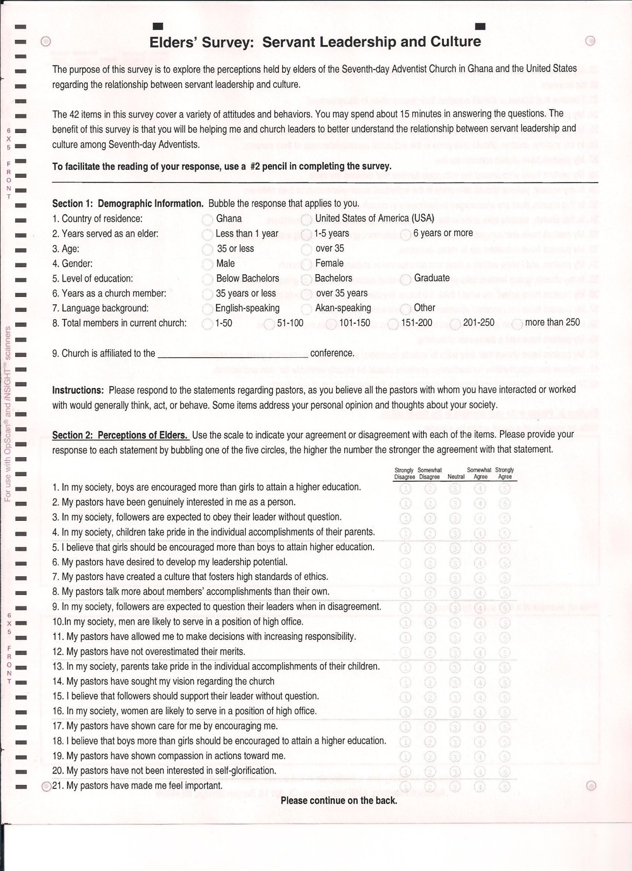

[Example] APPENDIX B

CORRESPONDENCE

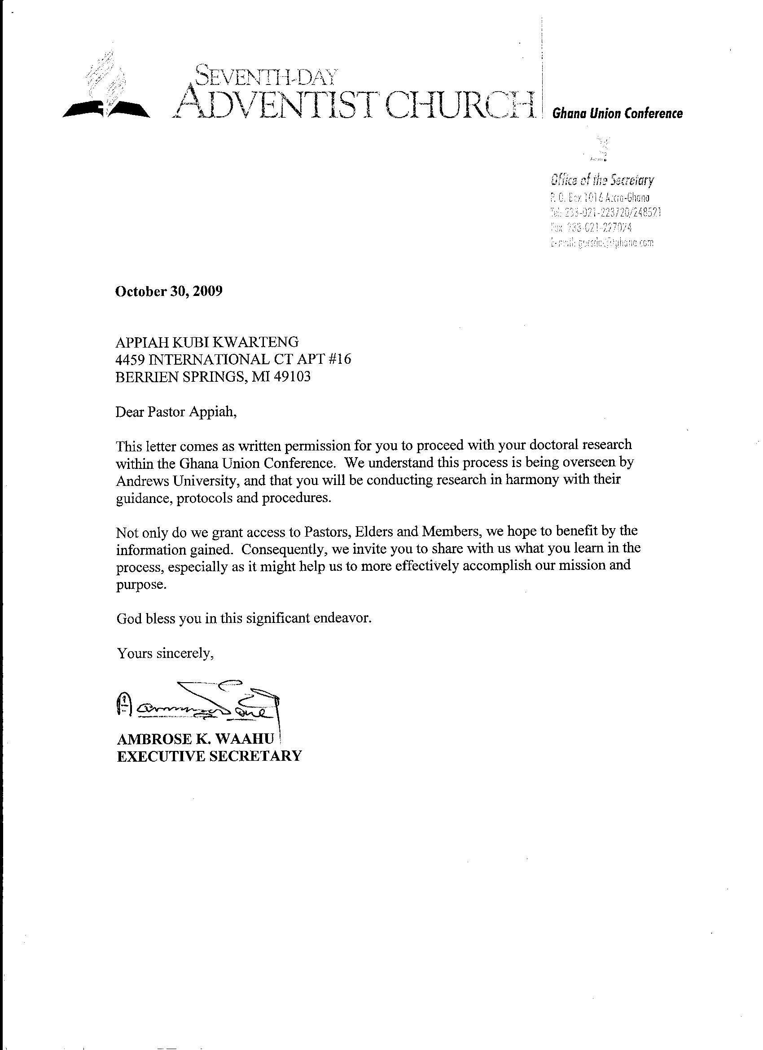

[Example] APPENDIX C

ANALYSIS OF VARIANCE

[Example] APPENDIX D

MAPS OF FIELDS OF THIS STUDY

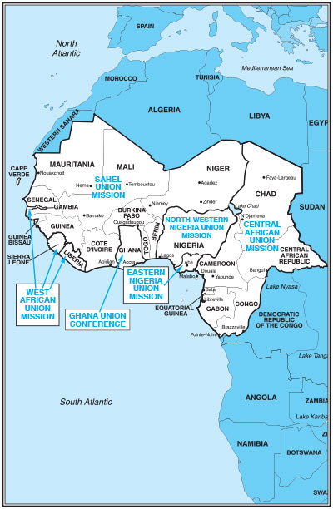

Map showing Ghana Union Conference as part of West Central Africa Division

[Example] APPENDIX E

DESCRIPTION OF VARIABLES

[Example] Description of Variables

Variable | Description | Survey items | Objective
Agapao Love | Measures the degree to which a servant leader demonstrates meaning and purpose on the job where the employee has the ability to realize his or her full potential as a person and feels like he or she is associated with a good and/or ethical organization. | Response to items 2, 7, 17, 19, 21, 27 | To measure the variable, I added each item score as indicated by each respondent, and arrived at a total score between 6-30 points. An exact interval scale
Empowerment | Measures the degree to which a servant leader empowers information to others: positive emotional support, actual experience of task mastery, observing models of success, and words of encouragement | Response to items 6, 11, 24, 25, 28, 33 | To measure the variable, I added each item score as indicated by each respondent, and arrived at a total score between 6-30 points. An exact interval scale
Vision | Measures the degree to which a servant leader incorporates the participation of all involved players in creating a shared vision for the organization | Response to items 14, 32, 34, 36, 40, 42 | To measure the variable, I added each item score as indicated by each respondent, and arrived at a total score between 6-30 points. An exact interval scale
Humility | Measures the degree to which a servant leader keeps his or her own accomplishments and talents in perspective, which includes self-acceptance, and further includes the idea of true humility as not being self-focused but rather focused on others | Response to items 8,12,20,22,37,39 | To measure the variable, I added each item score as indicated by each respondent, and arrived at a total score between 6-30 points. An exact interval scale
Power Distance | Measures the degree to which members of an organization or society expect and agree that power should be stratified and concentrated at higher levels of an organization or government. | Response to items 3, 9, 15, 23, 30, 38 | To measure the variable, I added each item score as indicated by each respondent, and arrived at a total score between 6-30 points. An exact interval scale
Gender Egalitarianism | Measures the degree to which an organization or a society minimizes gender role differences while promoting gender equality | Response to items 1, 5, 10, 16, 18, 41 | To measure the variable, I added each item score as indicated by each respondent, and arrived at a total score between 6-30 points. An exact interval scale
In-Group Collectivism | Measures the degree to which individuals express pride, loyalty, and cohesiveness in their organizations, or families | Response to items  4, 13, 26, 29, 31, 35 | To measure the variable, I added each item score as indicated by each respondent, and arrived at a total score between 6-30 points. An exact interval scale

[Example] REFERENCE LIST

REFERENCE LIST

Akosah-Sarpong, K. (2005, June 29). Rejoinder: Africa’s complicated leadership past the-case of Ghana. Retrieved fromhttp://www.modernghana.com/news/117322/1/ re-africas-complicated-past-the-case-of.html.

Banutu-Gomez, M. B. (2001). The concept of intergenerational leadership: A study of the influence of traditional African leadership practices in government organizational culture, in the Gambia, West Africa (Unpublished doctoral dissertation). Case Western Reserve University, Ohio. Retrieved from ProQuest Digital Dissertations database (Publication No. AAT 3001091).

Barbuto, E. J., Jr., & Wheeler, W. D. (2006). Scale development and construct clarification of servant leadership. Group Organization Management, 31, 300.

Barrett, C. (2006). Southwest Airlines' Colleen Barrett flies high on fuel hedging and 'Servant Leadership. Retrieved from http://knowledge.wharton.upenn.edu/ article.cfm?articleid=2006.

Barrett, C. (2009). Southwest Airlines’ Colleen Barrett Flies High on Fuel Hedging and ‘Servant Leadership Retrieved from: http://knowledge.wharton.upenn.edu/article/southwest-airlines-colleen-barrett-flies-high-on-fuel-hedging-and-servant-leadership/

Bass, B. M. (1985). Leadership and performance beyond expectations. New York: Free Press.

Bass, B.M. (1997). Does the transactional-transformational paradigm transcend organizational and national boundaries? American Psychologist, 22(2), 130-14.

Bass, B. M. (1999). On the taming of charisma: A reply to Janice Beyer. Leadership Quarterly, 10(4), 541-553.

Bass, B. M., & Avolio. B. J. (1994). Improving organizational effectiveness through transformational leadership. Thousand Oaks. CA: Sage.

Bass, B. M., & Steidlmeier, P. (1999). Ethics, character, and authentic transformational leadership. Leadership Quarterly, 10(4), 181-217.

[Example] VITA

VITA

EDUCATION
2004-Present PhD candidate in Leadership
Andrews University Berrien Springs, MI

2004-2006 CPE Units I & II
St. Joseph Regional Med. Center South Bend, IN

2001-2004 Master of Divinity
Andrews University Berrien Springs, MI

1988-1992 MA Pastoral Ministry
Andrews University
(Babcock University Campus) Illishan, Nigeria

1981-1985 BA (Honors) Sociology with Political Science
University of Ghana Accra, Ghana

PROFESSIONAL EXPERIENCE
2013-Present Pastor Philadelphia

2003-2013 Elder, Pioneer Memorial Church Berrien Springs, MI

2008-2009 Research Assistant to Dr. Baumgartner Berrien Springs, MI

1997-2001 President, Midwest Ghana Conference Sunyani, Ghana

