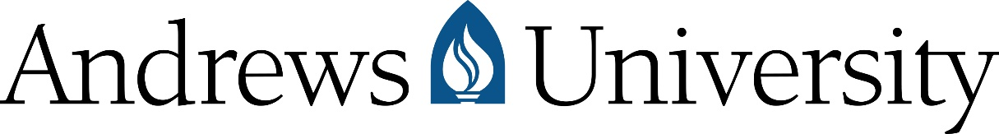

RELEASE AGREEMENT FOR CLASSROOM RECORDINGS

This Release Agreement relates to the participation of the undersigned student in course #________________ during the ____________ Semester of ______ (the “Course”).

I, the undersigned Participant, hereby grant Andrews University and its agents the right to capture my image, voice, and likeness through photographs, video recordings, audio recordings, television broadcasts, duplications, and other recording methods ("the recordings") during the Course. Additionally, I grant the university the continuous and unlimited right to use these recording.

I acknowledge that these recordings are owned by Andrews University and that the university has the full right to use, display, publish, distribute, and broadcast these recordings across various mediums at its discretion.

I understand that I will not receive any compensation for my participation in these recordings or for any use of the recordings.

I release Andrews University, along with its trustees, employees, and agents, from all liabilities arising from the use of these recordings. This includes, but is not limited to, any claims related to privacy rights, publicity rights, libel, slander, copyright or trademark violations, or portrayal in a false light.

I acknowledge that this Release Agreement is a legal document governed by the laws of the State of Michigan. I confirm that I have read, understood, and am signing this agreement voluntarily.

Printed Name of Participant Date

_________________________________________________________________________________________________
Signature (of parent or legal guardian in Participant is under the age of 18)

_________________________________________________________________________________________________
Email address Phone number

