Learning Hub Quick Reference Guide: Document Exams
□ How do I create an exam, where the students download word document and upload it back in LH. | Information:  - You can create a Word exam and have it in LearningHub for the students to download and take the exam, then upload up it back into the LearningHub during a specific period of time.  Note: the quiz tool is also what is used for exam
□ How do I set up the exam to be a word document. | How to:  - Go to your course  - Turn editing on  - Click on add an activity/resource  - Click on quiz  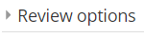  - Click add  - Name the quiz/exam  - You may need to click on the arrow pointing to the left to open a section of the setup  - Set up the dates and times for the quiz/exam to open and close  - Put in the time the quiz/exam should be allowed  - When time expires: Leave it at Open attempts are submitted automatically  - Under Review option, click on the checkmark for the attempt to uncheck the review options except the points and overall feedback. Those should remain checked.  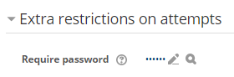  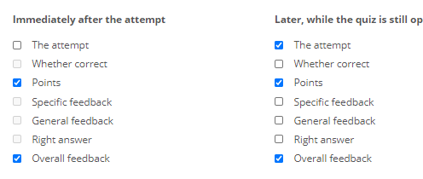  - Open Extra Restrictions on attempts  - Click the pencil icon to put in a password  - Put in a password  - Click Save and display  - Click on Edit quiz  - Click on down arrow to the right of Add  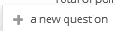  - Click + a new question  - Choose Essay  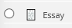  - Click Add  - For question name put in the name of the test  - For question Text  Download this Word File test and complete the questions.  Upload your saved Word file in the space below before the time expires. Your proctor will have you delete the file from your computer after uploading.  - Highlight Word file  - Click on the link  - Click Browse repositories…  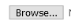  - Click Browse  - Find the Word document on your computer  - Double click on it  - You will then see the name of the file next to Browse…  - Click Upload this file  - Under Default points, but in the amount the quiz/exam is worth  - Open response options  - Response format: select No online text  - Attachments allowed: 1  - Required attachments: 1  - Accepted files types: click on Choose document  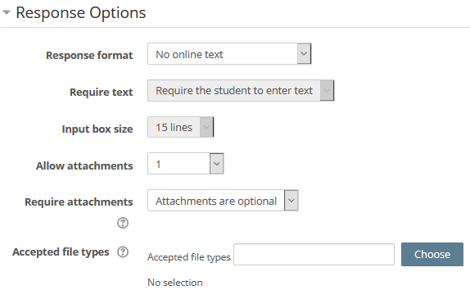  - Select Document files  - Scroll down and click save changes  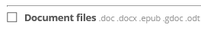  - Scroll to the bottom and click save changes  - Make sure Total points match maximum grade  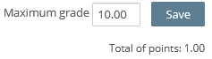  - Click into Maximum grade and change the point value to match total points  - Click Save  The quiz/exam is now ready for the students

