**General Physics eJournal 9**

**Image Formation by a Thin Lens**

**Instructions:**

Follow the Writeup and fill out the eJournal as you complete the lab activities. Submit your eJournal report by uploading the completed WORD or PDF document to our class Learninghub site. If the Learninghub site is down, email the completed report file directly to a lab TA.

**Preliminaries:**

* Title:
* Name(s):
* Date:
* Time In & Out:

**Plan:**

**Hypothesis**

Form a hypothesis regarding the relationship between object and image distances for a converging lens with s > f.

As part of your hypothesis, complete the ray trace for three rays started below. You may complete the diagram digitally or on paper. Add your lines on top of the original diagram or insert a picture below of your completed ray trace.

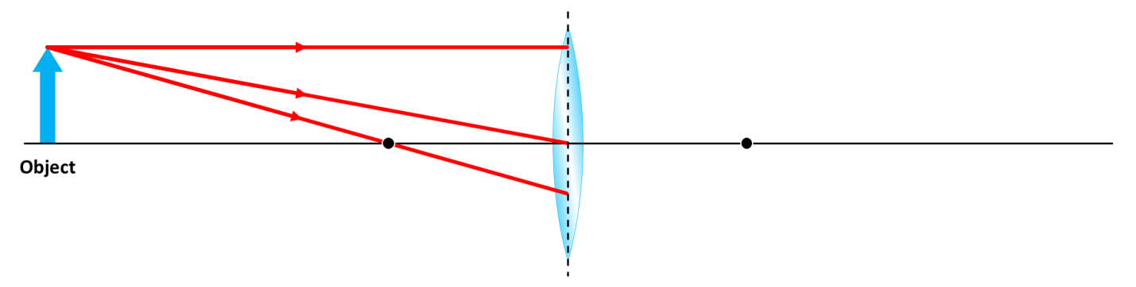

*Insert image of your completed ray trace (or add to the diagram above)*

**Experiment Outline**

Briefly describe your plan for testing your hypothesis.

**Equipment List**

* List
* Equipment
* Here

**Action:**

Describe the techniques used to collect data by responding to the bullet point questions:

* How did you measure the focal length?
* What did you use for an object?
* How did you view the image produced by the lens (i.e. what did you use for a screen)?
* How did you measure the object distance?
* How did you measure the image distance?
* How did you determine the magnification of the lens at a certain object distance?

*Insert labeled image of your apparatus*

**Results:**

Record the measured focal length of the lens.

Measured Focal Length, f = _____________ cm

Record at least 6 pairs of object and image distances.

**Table I: Object/Image Distances for a Converging Lens with s > f**

|  |  |
| --- | --- |
| **Object Distance, s (cm)** | **Image Distance, s’ (cm)** |
|  |  |
|  |  |
|  |  |
|  |  |
|  |  |
|  |  |

Record the object height, y, image height, y’, and image distance, s’, for an object distance of   
s = 40 cm. Remember that for an inverted (upside-down) image, the image height, y’, is negative.

**Table II: Object/Image Distances and Heights at s = 40 cm**

|  |  |  |  |
| --- | --- | --- | --- |
| **Object Distance, s (cm)** | **Image Distance, s’ (cm)** | **Object Height, y (cm)** | **Image Height, y’ (cm)** |
| 40 |  |  |  |

**Analysis:**

Generate a plot of 1/s’ (y-axis) vs. 1/s (x-axis). Apply a linear fit and record the slope, m, and inverted y-intercept, 1/b.

*Insert graph of 1/s’ vs 1/s*

Compare the slope, m, to the predicted slope, -1.

**Table III: Compare Slope to -1**

|  |  |  |
| --- | --- | --- |
| **Predicted Slope** | **Measured Slope, m** | **% Error** |
| -1 |  |  |

Compare the inverted y-intercept, 1/b, to the measured focal length, f.

**Table IV: Compare 1/y-intercept to Measured Focal Length**

|  |  |  |
| --- | --- | --- |
| **Measured Focal Length, f (cm)** | **1/b (cm)** | **% Difference** |
|  |  |  |

Compare the predicted and measured lateral magnifications at s = 40 cm.

**Table V: Compare Predicted and Measured Lateral Magnification at s = 40 cm.**

|  |  |  |
| --- | --- | --- |
| **Predicted Magnification, mpred** | **Measured Magnification, mmeas** | **% Difference** |
|  |  |  |

**Conclusion:**

Interpret your results in light of your hypothetical predictions. How well did your hypothesis and predictions match the results? If your results produced a large error, what do you think was the largest contributing factor and what could you have done differently to avoid this error? How might you improve this experiment or explore it further?